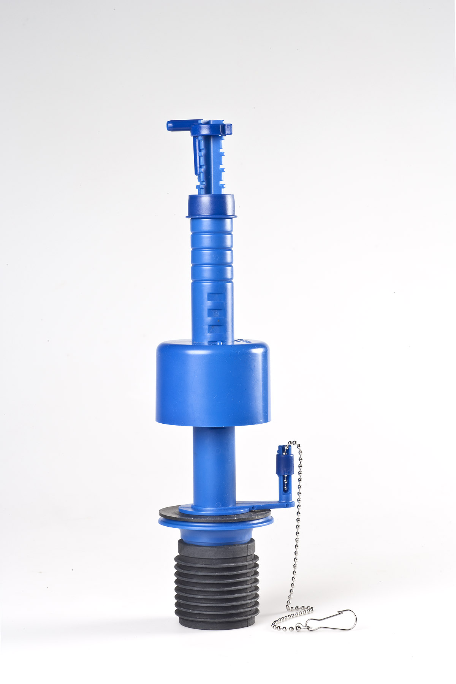 |  | Purpose  This patented dual-flush valve is intended for replacement of single flush valves in water tanks of lever-operated toilets:  - For the upgrade of single flush toilets with lever  - Saves from 15 to more than 30% of water used for flushing  - Easy to use  - Easy fitting (please refer to our website)  - No maintenance  - Adjustable reduced flush levels
Use is simple
Small flush: Press and let go
Large flush: Press and hold

Technical data
Lever

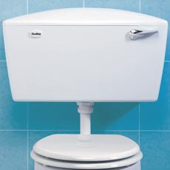
1,5” outlet

1.5” drop down valve | Lever activated
Cistern outlet hole diameter: | D = 48-52 mm
Inner width of water tank at bottom: | W = Min. 88 mm
Height | H = 352-412 mm (without shortening of valve shaft)

Intended use
The ecoBETA® ecoFLUSH dual flush valve (SNA) can be fitted in most lever operated toilet makes and models in replacement of single-flush valves with a view to conserve water:
- By upgrading the single flush toilet to a water-saving dual flush toilet. The design has a huge impact on people’s behaviour as they must make an extra effort to use water by holding the lever for a few seconds for the large flush. Therefore, users do not activate the large flush when only the small flush is required.
- By interrupting the large flush when the lever is released.
- No risk of leakage due to breakage or deposit of scale.
- By allowing easy adjustment of the small flush to the minimum volume required.

Benefits in general
- By specifying the ecoBETA® dual-flush, our customers gain considerable water savings.
- User-friendly, intuitive/easy to operate: Use of the ecoBETA® dual flush causes no discomfort for the user.
- Reliable: Hardly any maintenance or risk of continuously running water
- Cost effective: The ecoBETA® dual-flush solution provides high value for money water savings.

Benefits in relation to the user
- Simple to use: For the small flush, just press and release. For the large flush, hold the lever for 1-2 seconds.
- High level of user satisfaction
- Minimizes the need for maintenance due to continuously running water

Benefits in relation to water management
- Significant water savings
- Water companies gain overall cost savings on pumping, transport and purification of wastewater as less water is consumed.
- The ecoBETA® dual-flush constitutes a feasible option to tackle the balance between water supply and demand and security of supply in a way that is economically, socially and environmentally sustainable. This water efficiency measure should be combined with other water saving products as well as other measures including behaviour changes and raising awareness.

Technical benefits
- The ecoBETA® ecoFLUSH dual-flush valve is operated by lever, upwards or downwards, and designed for replacement of single flush valves in a wide range of toilet makes and models.
- The ecoBETA® dual-flush saves water.
- The small flush level can be adjusted to the amount of water required by the toilet bowl and the sewage system, from 2½ litres to 5 litres or more. The ecoBETA® dual-flush does not affect the full flush volume.
- Easy installation/retrofitting by certified installer
- When fitted, the ecoBETA® ecoFLUSH dual-flush valve is a discreet and integral part of the toilet design.
- The ecoBETA® ecoFLSUH dual-flush valve is made up of only few parts. The sturdy and simple construction and functional design ensures operational reliability and minimizes the risk of malfunction due to breakage or deposits of scale. The only need for maintenance is when the gasket requires replacement every 6-8 years.

